Class Documentation

# User

This class is used for manipulating and creating users in the trading platform storing their identification details and passwords encrypted. Different types of users will be subclasses of users who have different authority in the system - admin and staff 🡪 lead and employee.

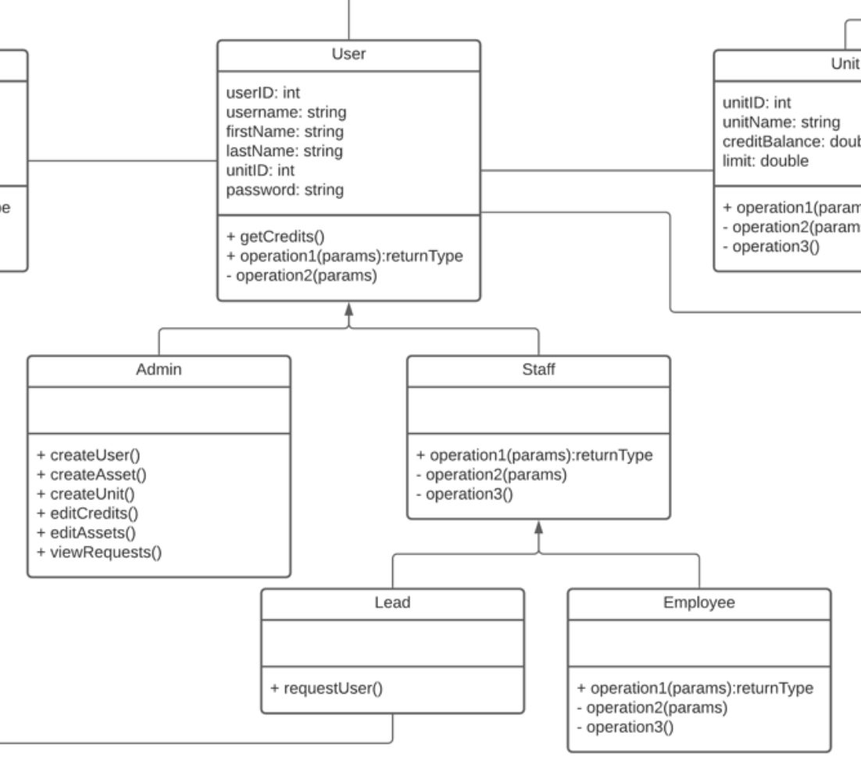

# Unit

This class is responsible for identifying an organisation unit and how a unit may interact with other units/ with other users. The units are the basis in the trades as all trades are executed through a unit.

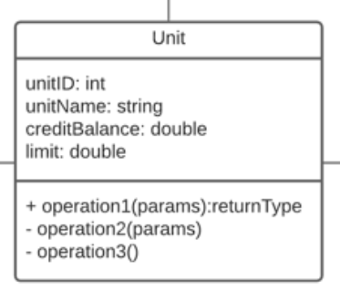

# Asset

Different assets can be traded on the platform and must hold similar variables to be traded on the marketplace. Unit’s can create new units to be traded within the organisation.

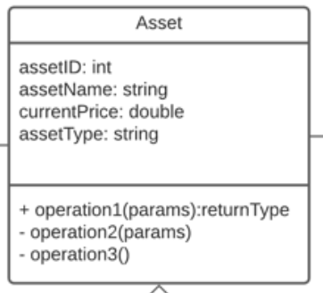

# Order

Performing a trade on the platform will be executed through the order class. It will identify whether the order has been executed or is still pending. Trades require mandatory fields to align the needs of buyers and sellers.

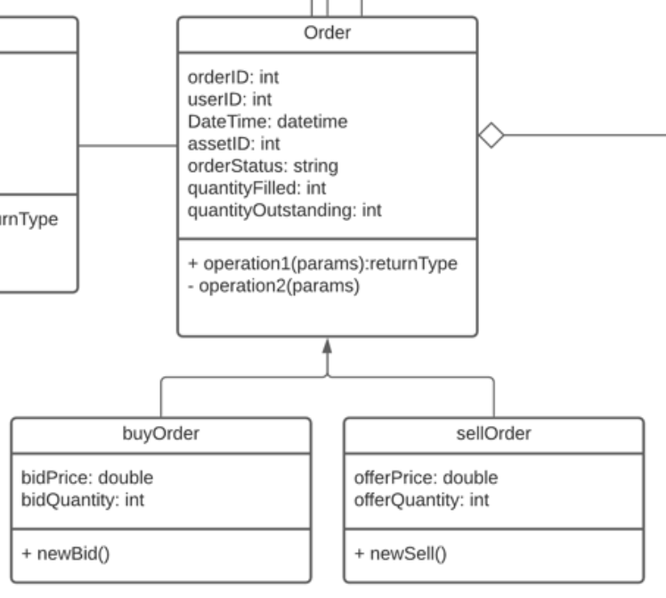

# Notification

A simple class used to create notifications to improve user experience. It will store information like ‘order executed’, ‘new user created’, etc

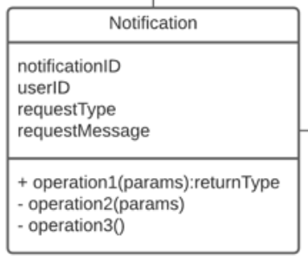

# Request

Organisational unit leads will be able to request the addition of new users, assets and other requests that will be sent to the systems admin.

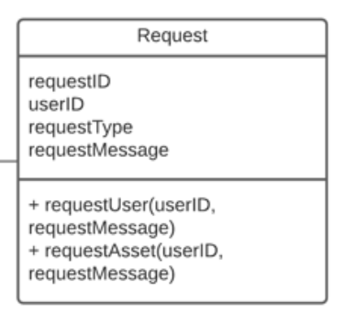

# Inventory

Inventory class responsible for manipulating inventory figures and will interact dynamically with trades that occur. Each organisational unit will have an individual inventory.

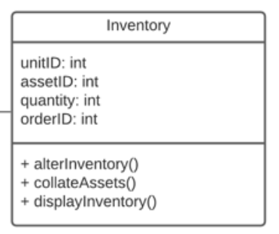

# Watchlist

Each organisational unit will be able to track assets they are interested in and this class will store that information.

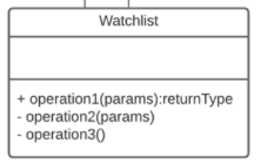

UPDATE WITH NEW CLASS DIAGRAM

* Add unit_id, asset_id to watch list fields

